1. **Landing page image/images. Your taglines, captions.: Use the elevation of building, and the gate close up view**

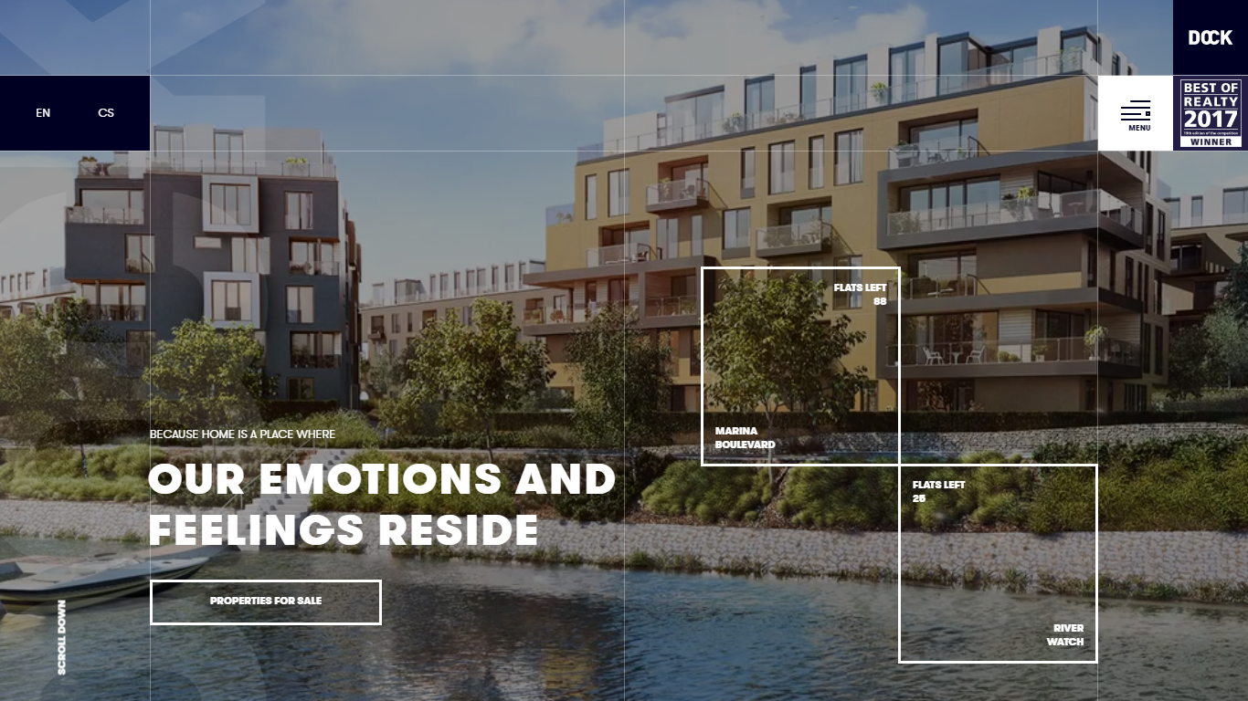

1. **Menu Style – In image it is an overlay effect. Choose your menu style and menu list.**

**:Use Dock style menu bar**

1. **Dock style (naming it so, for your convenience)**

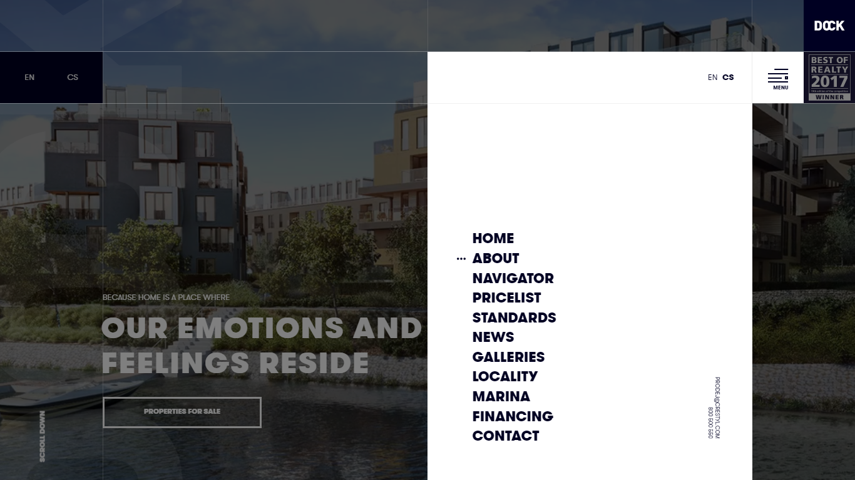

b-Full screen menu

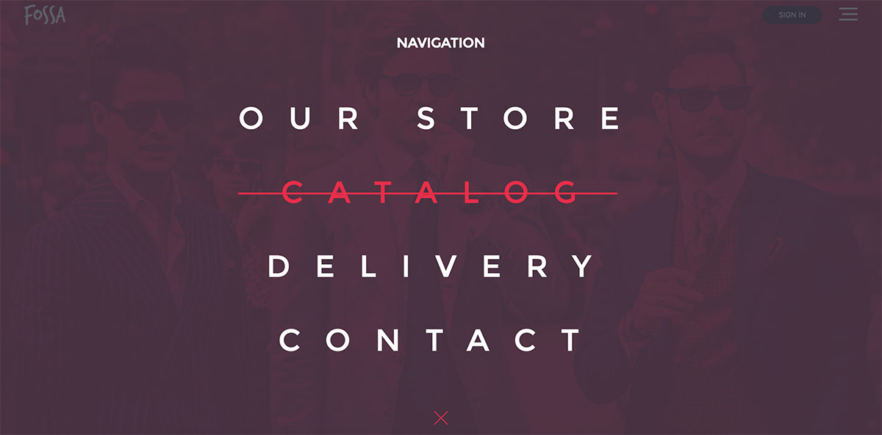

C- Top Navbar

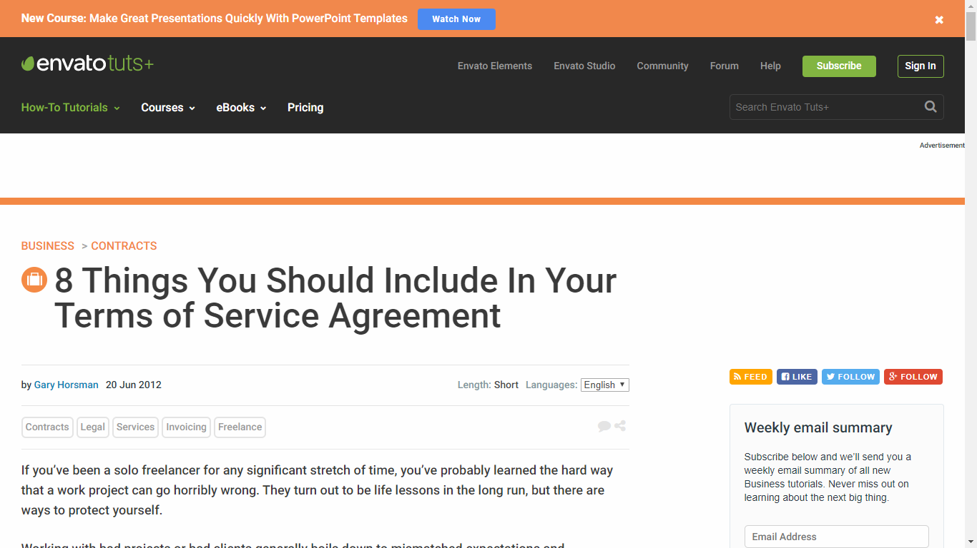

1. Your Project information and images

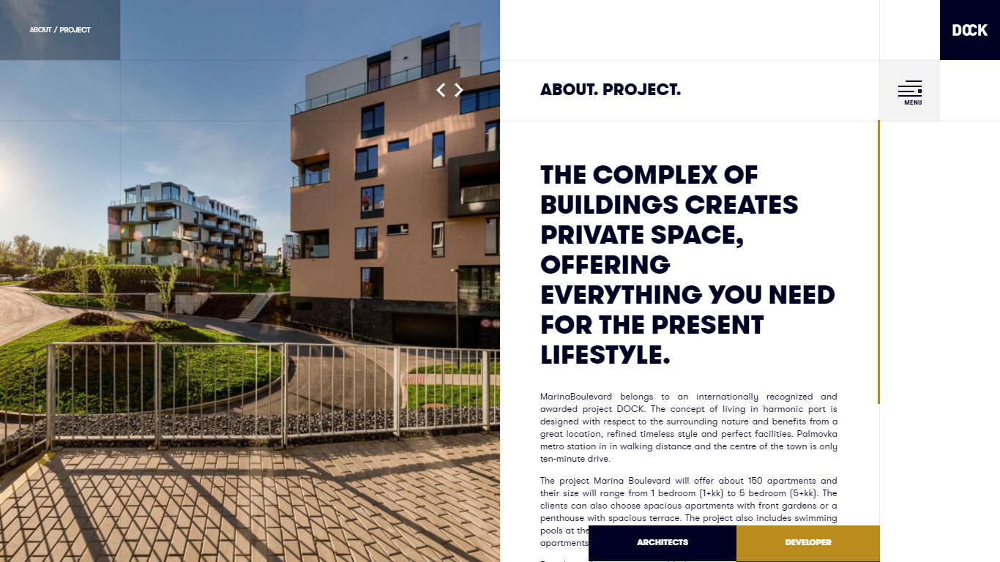

4-What will be your Price Listing format? – Dynamic page. Contents on this page will be changed from admin page.

:Instead of Price list we can make it as availability chart

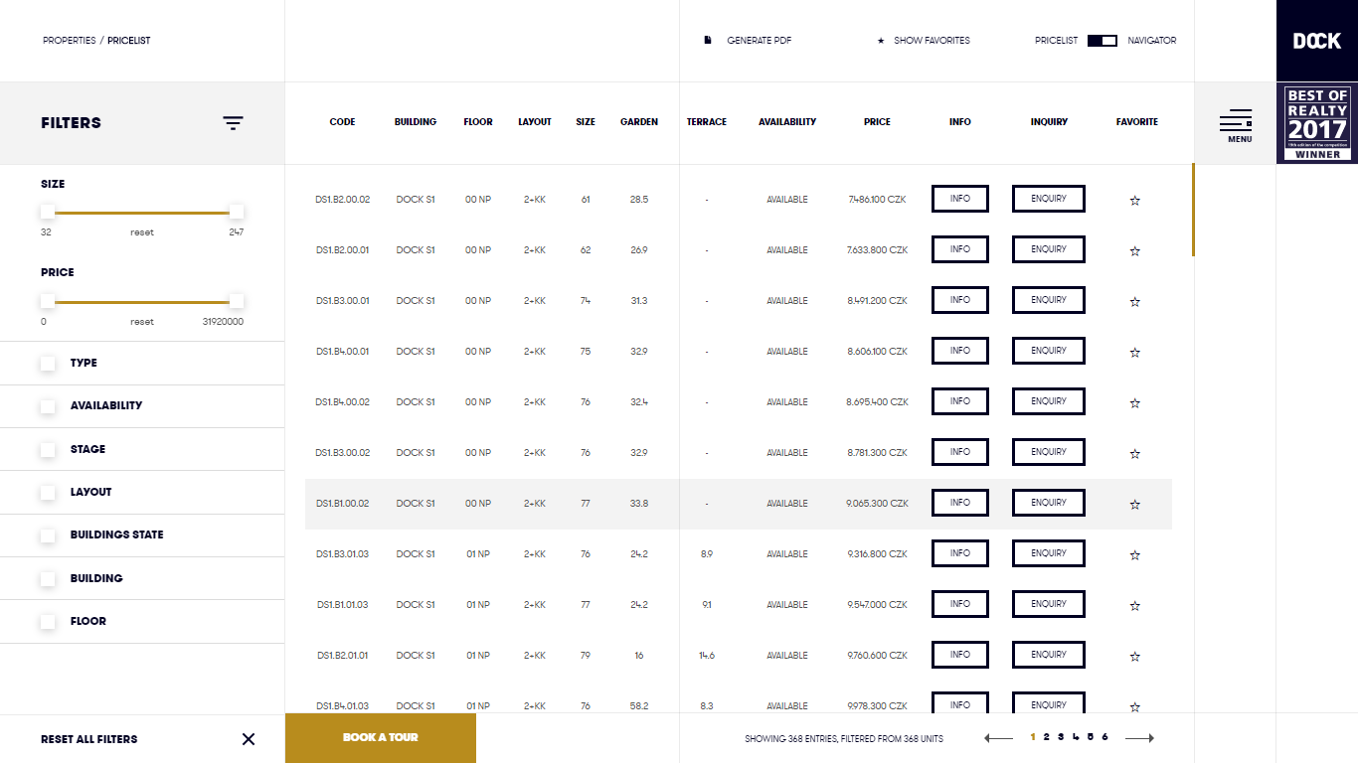

1. Information for this page. – This page will be static

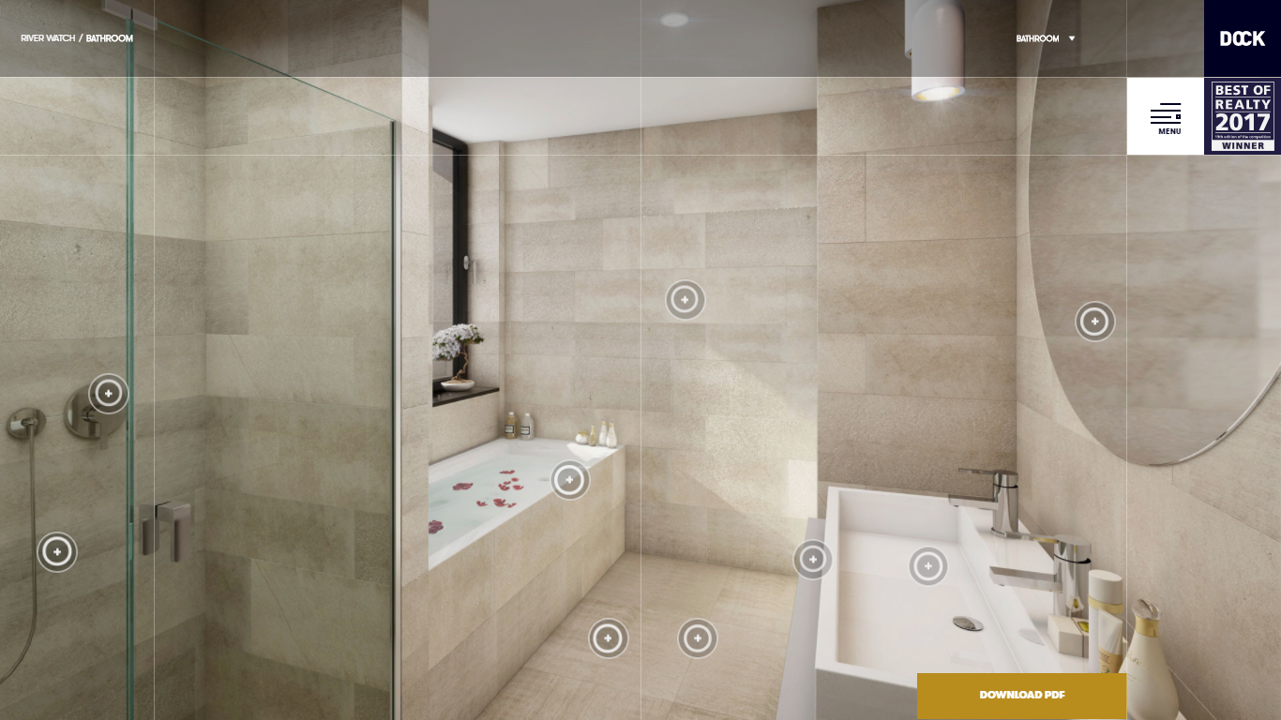

1. If you have been part of the news – This page will be static

:We can add some certificates shall share you

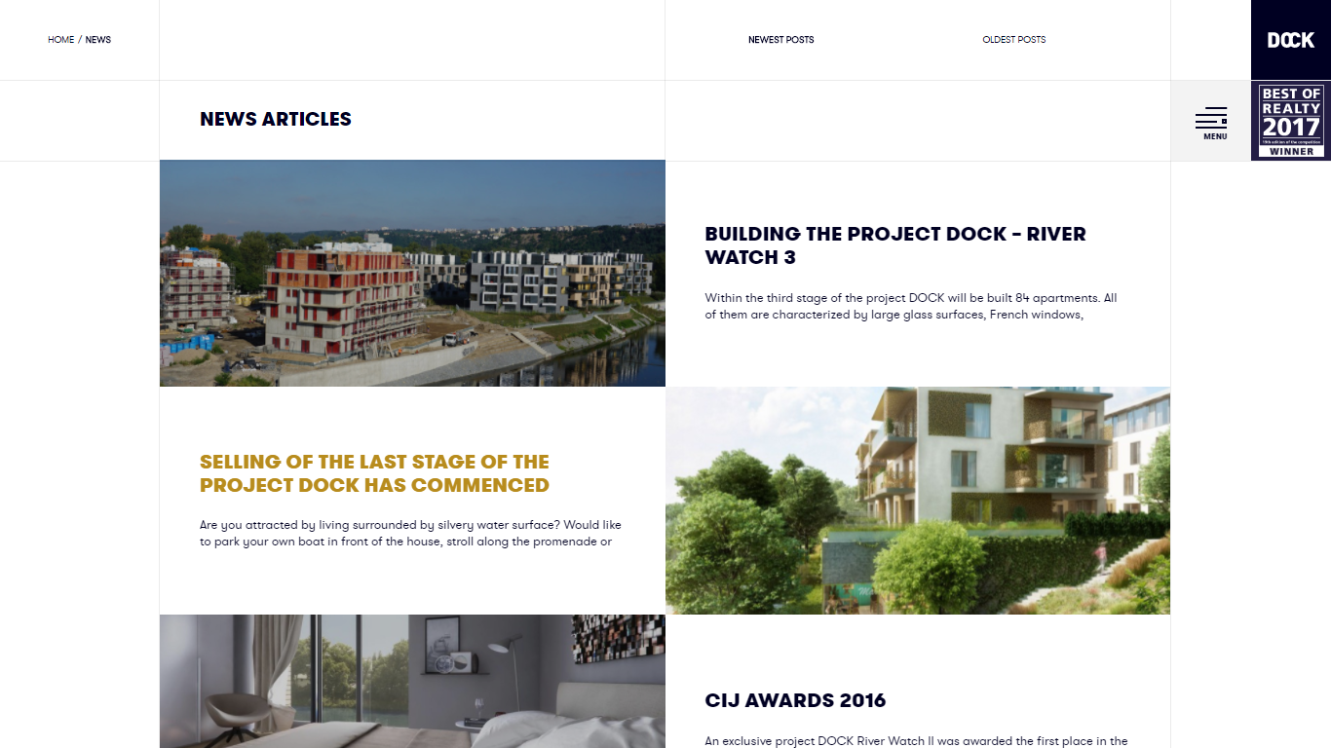

Images for Gallery – Static page.

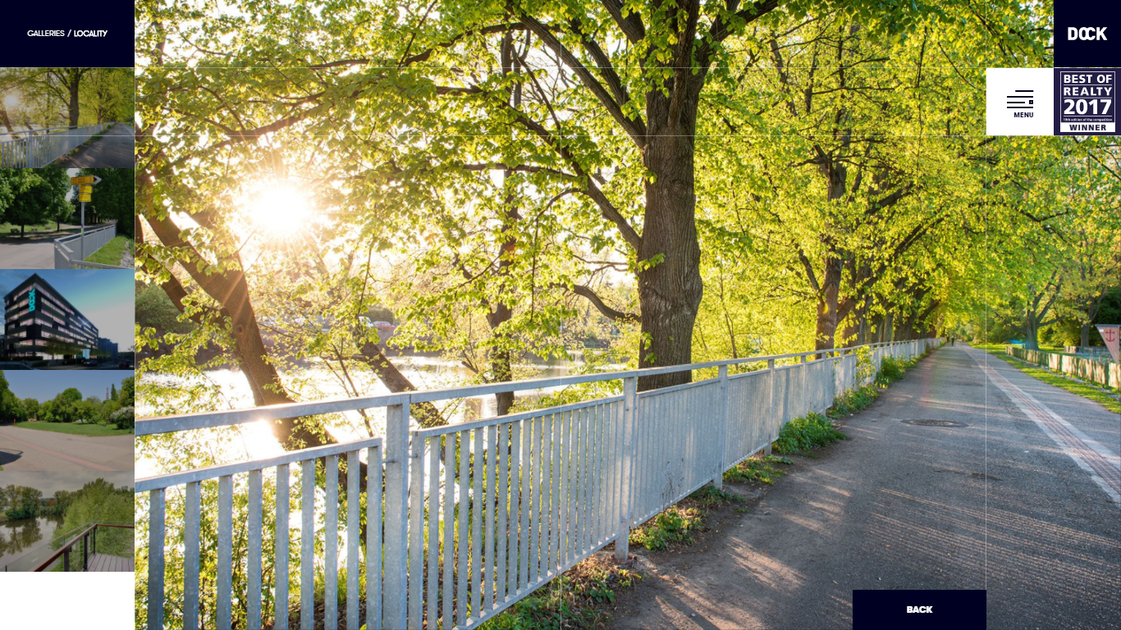

Locality: If you want to include such map, then you must know that this service is provided by google, which free up to certain usage, it may stop working after the limit. Or show **just** location for free.

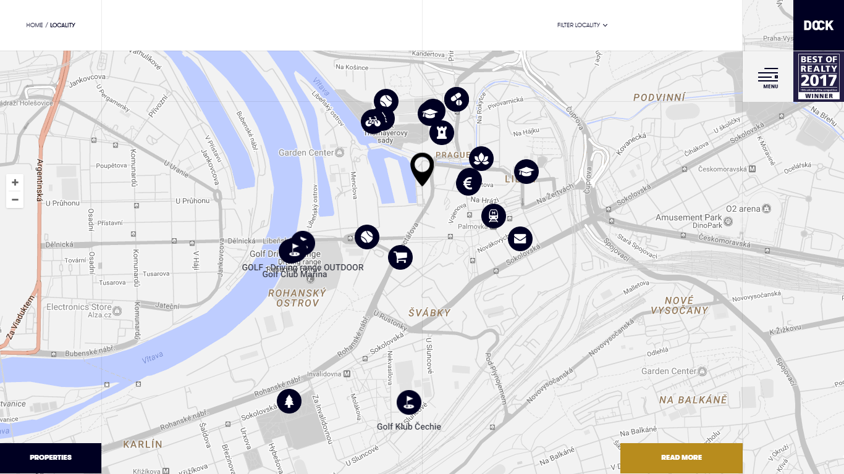

Anything exotic like this?

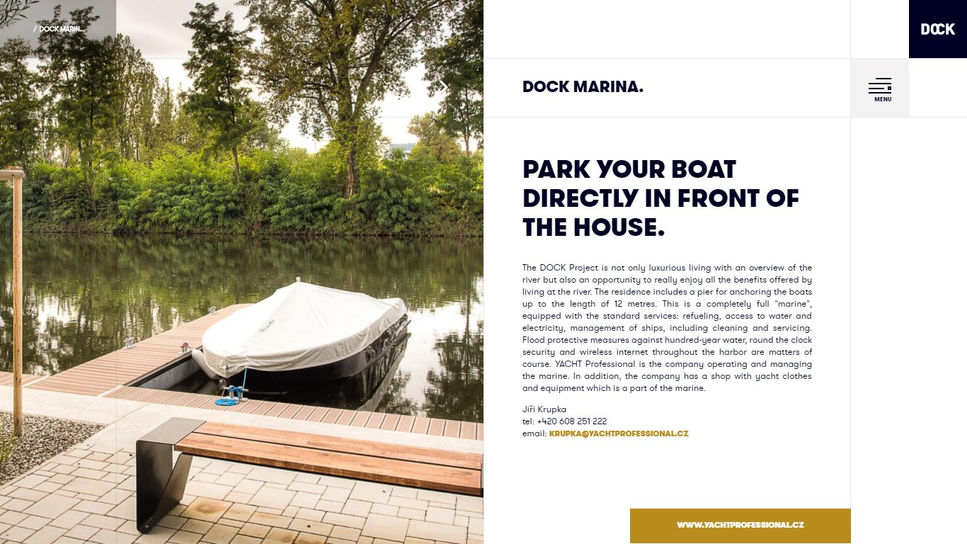

Contact information

: What is the risk in this?

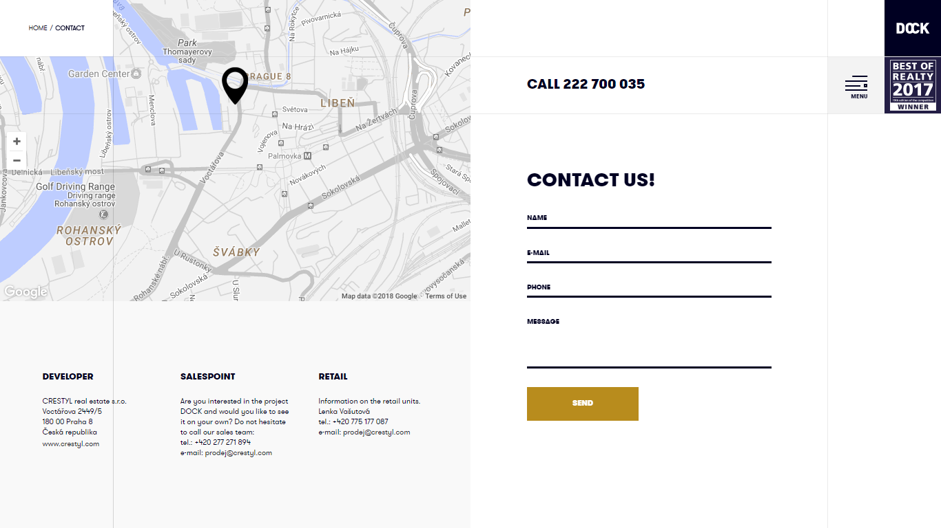

Our advice would be just posting you email address instead of such contact form, to reduce risk as there is information of your clients.

Summary of Required information:

-Information about the project.- shall share a draft to you

-Do we have any club house or some extra feature which we can say it as USP do share.

- Images with its information.

eg. Images of bedroom, with information about tiles, colors, fixtures, fittings etc.

- Information you're providing to registered users to see after they log in.

- Specific colors you want on website and those that you don't want.: no restriction as such

- Social media account links if any.: Yes FB

- Achievements that you want to showcase.

- Testimonials/Reviews: Customer feedback if you want to display, with their name and picture if possible. : Add Feedback form

_____________________________________________________________________________________

Under customer profile

* Personal Information.: Personal info name, address, contact no,
* General Ledger.
* Booking Status.: Booked, Agreement done,
* Construction Updates.: Photos, Videos
* Documents General. Plans, noc, certificates
* Letters Receipt.
* Request Suggestion.: Suggestion to Builder from client
* Refer A Friend. (What is your idea behind this?): create a form for it.

What will be the information under each tab?